1. Appearance

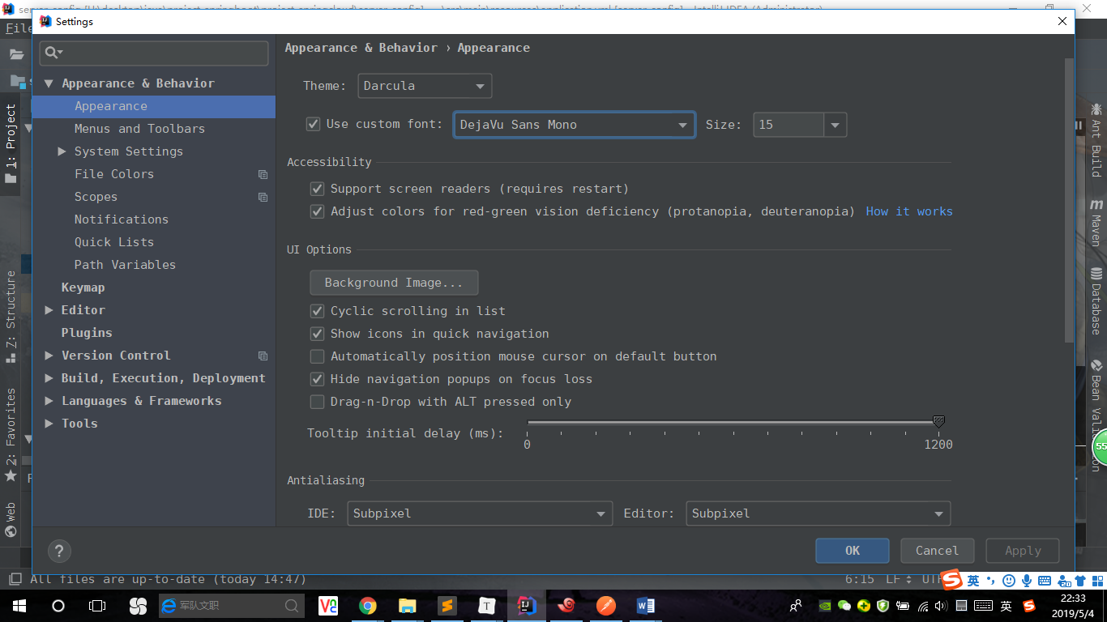

1. Background Image

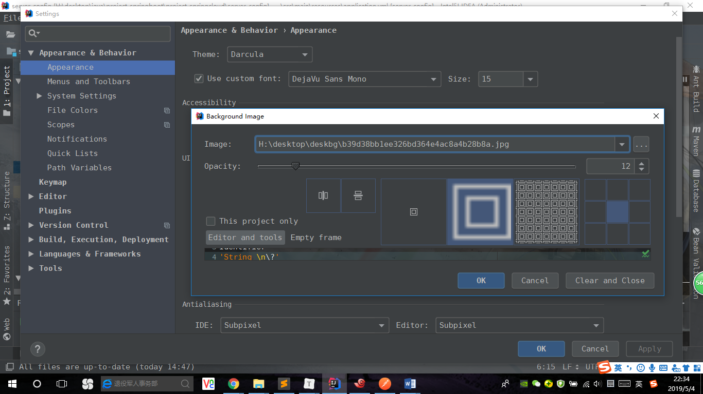

1. Font 🡪 Font

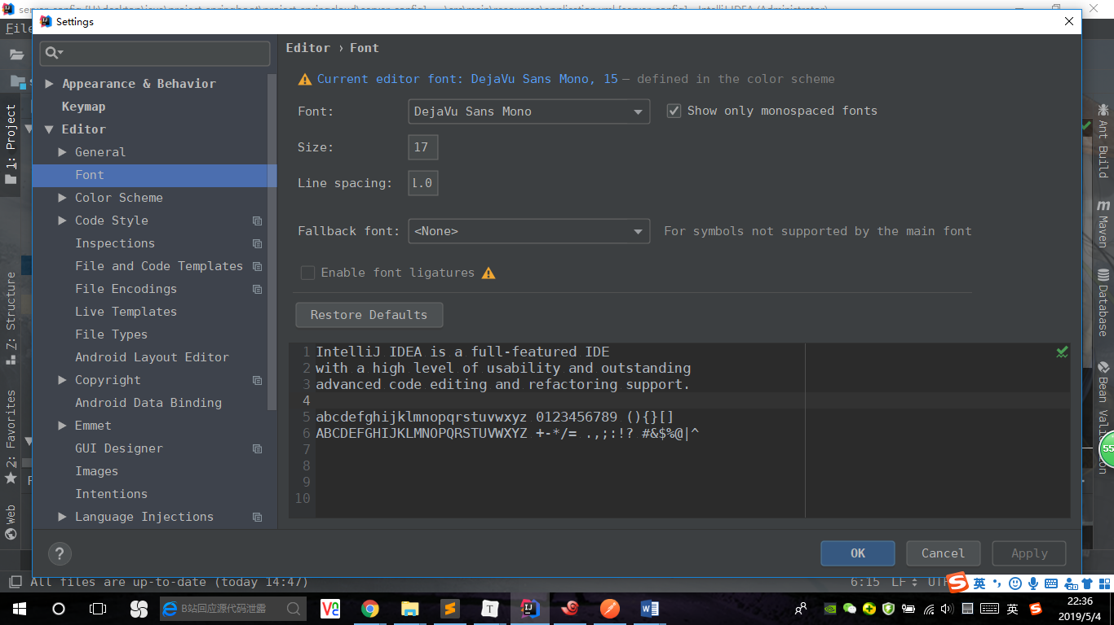

1. Editor 🡪 Color Scheme 🡪 Color Scheme Font

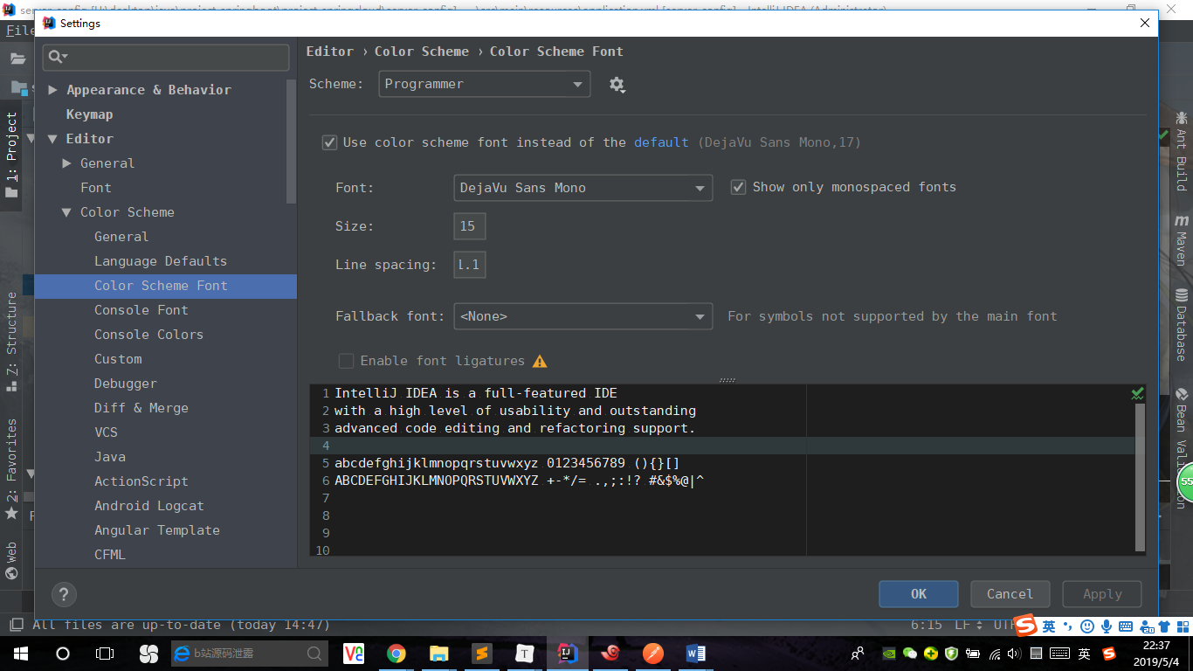

1. Editor 🡪 Color Scheme 🡪 Console Font

